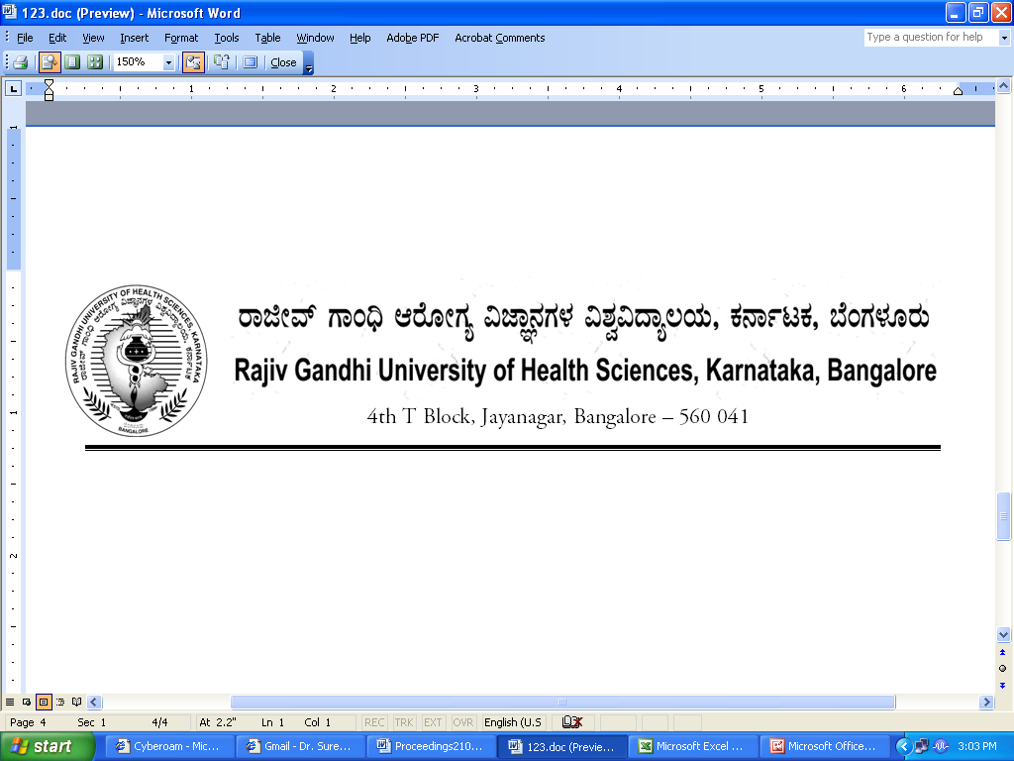
Reg(E)Exam/SPL/July- 2018 Date: 09/05/2018

To,

The Director / Dean / Principals of
All Super Specialty Colleges
Affiliated to RGUHS.

Sir / Madam,

Sub : | Providing the number of students appearing for Super Specialty course examination July- 2018.

With reference to the above, you are hereby requested to send the number of students appearing for July-2018 Super Specialty examination same may be forwarded in the following proforma on or before 31/05/2018 through email to drexamrguhs@gmail.com and an hardcopy to be sent without fail to speed up the examination process.
Super Specialty

Name of the Student | Register No | Name of the Course

Thanking you,

Yours faithfully,

Sd/-
Registrar [Evaluation]

An ounce of action is worth a ton of theory

